Proposal WeedManager Development Phase II

Testing and out-scaling an AndroidTM based weed management support tool for smallholder rice farmers in Africa

Proposed partners: AfricaRice (Abidjan, Côte d’Ivoire), Co-Capacity (Bunnik, The Netherlands), CARI (Abuja, Nigeria)
Proposed period: June 2017-June 20118
Budget requirement: US $51,000 (Contribution AfricaRice: US $ 21,000; Contribution CARI: US $ 30,000)
AfricaRice Project: RICE CRP and SMART-VALLEYS
Coordination AfricaRice: Jonne Rodenburg (j.rodenburg@cgiar.org)
Coordination CARI: Stefan Kachelriess-Matthess (stefan.kachelriess@giz.de)

- Executive summary
Smallholder rice farmers in Africa often have poor access to information and rely on public or private service-providers —like extension services— for advices on possible alternative weed management strategies. Efficacy of extension services in Africa however, is constrained by sub-optimal training and restricted access to adequate information on weed management. RiceAdvice-WeedManager —developed by AfricaRice and Co-Capacity and ready for testing under field conditions— is a freely downloadable application for Android based smartphones and e-tablets that addresses this status quo.
WeedManager assists service-providers in generating farm-specific advices for weed management to smallholder rice farmers, before, during and after the main rice-cropping season. WeedManager stimulates implementation of targeted and integrated weed management practices by smallholder rice farmers in Africa —reducing reliance on hand weeding— and thereby contributing to sustainable and affordable productivity enhancement leading to food security and income generation.
Starting in Nigeria and Tanzania, the WeedManager tool will be tested, fine-tuned and out-scaled in the coming three years (if funds are available) with farmers under irrigated and rain-fed upland and lowland conditions, impact will be studied and outcomes will be communicated.

- Justification
Irrespective of ecosystem and geographical location, competition from weeds is one of the most important overarching constraints to rice production in Africa. Conservative estimates of weed-inflicted yield losses in rice in Africa are: 842,000 t (paddy) under irrigated, 756,000 t under rain-fed lowland and 648,000 t under rain-fed upland conditions. This results in at least US $1.5 billon losses per year. Effective management of weeds requires botanical, ecological, biological and agronomical knowledge on the one hand and availability of technologies and resources on the other hand. Rice farmers in Africa generally have limited knowledge on weed ecology, biology and control and limited available resources and technologies for the implementation of this knowledge. The most widely used method is therefore hand weeding, but this is extremely laborious and energy consuming. The consequence is that farmers spent far too much time on weeding, or they neglect weeding if other economic activities demand their attention at the same time, which will then result in huge yield losses. When weed management is neglected yield losses are estimated to range from 28 to 74% in transplanted lowland rice, 28 to 89% in direct-seeded lowland rice and 48 to 100% in upland ecosystems in West Africa. A tool that would help these farmers to detect the most effective management practice, given the location-specific problem as well as the set of resources or technologies that are available to them, would greatly enhance their capacities to effectively deal with weeds in a time-saving manner. Both the time-savings and the productivity enhancement resulting from that will benefit the households economies of these farmers tremendously.

- WeedManager
In Phase I, a beta-version of the tool RiceAdvice-WeedManager is developed by AfricaRice and Co-Capacity (Fig. 1). Using the same set-up as the already available tool RiceAdvice (Annex 1), it is an electronic application that can be run on any Android device, consisting of different steps that ultimately lead to tangible advices.
After installation and account creation, the first step is for the farmer, or the service provider, to generate a profile with information on the name and location of the farmer. Secondly, the farmer/service provider should characterize the farm and field conditions by going through a set of multiple-choice questions. The characterization includes basic information on the growing environment of the field (e.g. rain-fed upland, rain-fed lowland, irrigated lowland), water management (e.g. no, partial or full control over water), weed community characterization (e.g. dominant weed species/categories, weed infestation level), available inputs and equipment, financial assets/resources and market access. After completion of this questionnaire, the farmer/farmer-advisor will get advice(s) on the most suitable and effective weed management option(s) in his field, based on the selected answers. The advices will be sub-divided in recommendations for management before the season, during the season and after the season. More details can be obtained on knowledge-intensive advices such as herbicides. By clicking on the herbicide recommendations, details on useful products and application instructions are shown..
The farmer/service provider can then make a choice concerning the follow-up on these advices. It is important that such flexibility is built in, to accommodate for the large farm diversity in Africa; some recommendations may be more suitable for a specific farm than others and while combining implementation of several recommendations simultaneously will give the best results, improved weed control can already be attained by following up on just one or two of them.
WeedManager will ultimately be available for free through GooglePlay Store.

- Proposal for testing and improving WeedManager
In Phase II, the beta-version of WeedManager needs to be thoroughly tested. This phase will take one year and is necessary to test, fine-tune and improve the tool in terms of usability and quality of advices given and to identify areas for improved handling and usability.
The work will be done with a selected number of service providers — 10 per country— to pre-test the tool in the field with farmers. Each service provider could work with 10 farmers. Testing will be done at one site per country. Service-providers will be selected and trained during a one-day workshop, in the use of the tool and the communication and follow-up with farmers. A training/instruction video will be made available. After that training each service-provider will be assigned 10 farmers with whom he/she will work during the whole year (including the main season and pre- and post-season periods) in generating farm-specific WeedManager advices and in following up on these advices. Preferably each service provider works with a diverse set of farmers in terms of rice growing environment (irrigated lowland, rainfed lowland and rainfed upland), to enable a through test of the tool.
The pilot testing will be done according to a protocol (Annex 2. Page 9-16). Participating farmers will be asked to split their rice fields in two equal parts. On one half of the field farmers will repeat the weed management practices implemented in the previous seasons (henceforward referred to as ‘farmer practice’), while in the other half, the recommendations from WeedManager will be followed. For each farmer the ‘farmer practice’ will be discussed prior to the season and included in the seasonal planning. Following up on both the ‘farmer practice’ and the WeedManager practices will be done by the CARI technician involved in this work. This will result in 100 test cases per country. Farmers of each of these test cases will be interviewed prior and after the WeedManager test and their yield and weed control level will be assessed. The results from these test cases will be analyzed and this will be used to improve the tool for the following year.
In subsequent years, WeedManager will be further tested and disseminated by AfricaRice and CARI in Nigeria and Tanzania. Preparations will also be made for out-scaling of the tool in additional countries. The ATF and AfricaRice’s hub approach will play a major role in this activity. We will also disseminate promotional material such as an Infographic (Fig. 2) in folder and poster format to publicize the tool on conferences, workshops and on the websites of the project members as well as on professional and social media. We will make a Facebook page on WeedManager which we will regularly update with news items and statistics on use and impact. Further more a mailing list will be established to communicate internally, i.e. issue reporting, helpdesk, etc..

5. Planning
The Phase II planning (June 2017 – June 2018) is schematically presented in Table 1 below.

Table 1. Time planning of Phase II of the WeedManager project in Nigeria and Tanzania.
 | 2017 |  |  |  |  |  |  | 2018
Activity | J | J | A | S | O | N | D | J | F | M | A | M
SP¹ & farmer selection
SP training
Farmer tests
Surveys
Maintenance and critical bug fixing
Out-scaling & promotion
M&E
¹ SP= Service-provider

6. Budget
In Phase I (August 2015 – May 2017), comprising the development of the tool, the total investment by AfricaRice was US $67, 000 (Table 2).
The total budget requirement for Phase II (June 2017 – June 2018) is US $51,000, with $21,000 contributed by AfricaRice, and $30,000 contributed by CARI (Table 2). AfricaRice will pay salary costs of the Weed Management specialist and the tool maintenance and repair costs (through a sub-agreement between AfricaRice and Co-Capacity).

Table 2. Budget (in US $) for Phase I (August 2015-May 2017) and Phase II (June 2017 – June 2018) of WeedManager development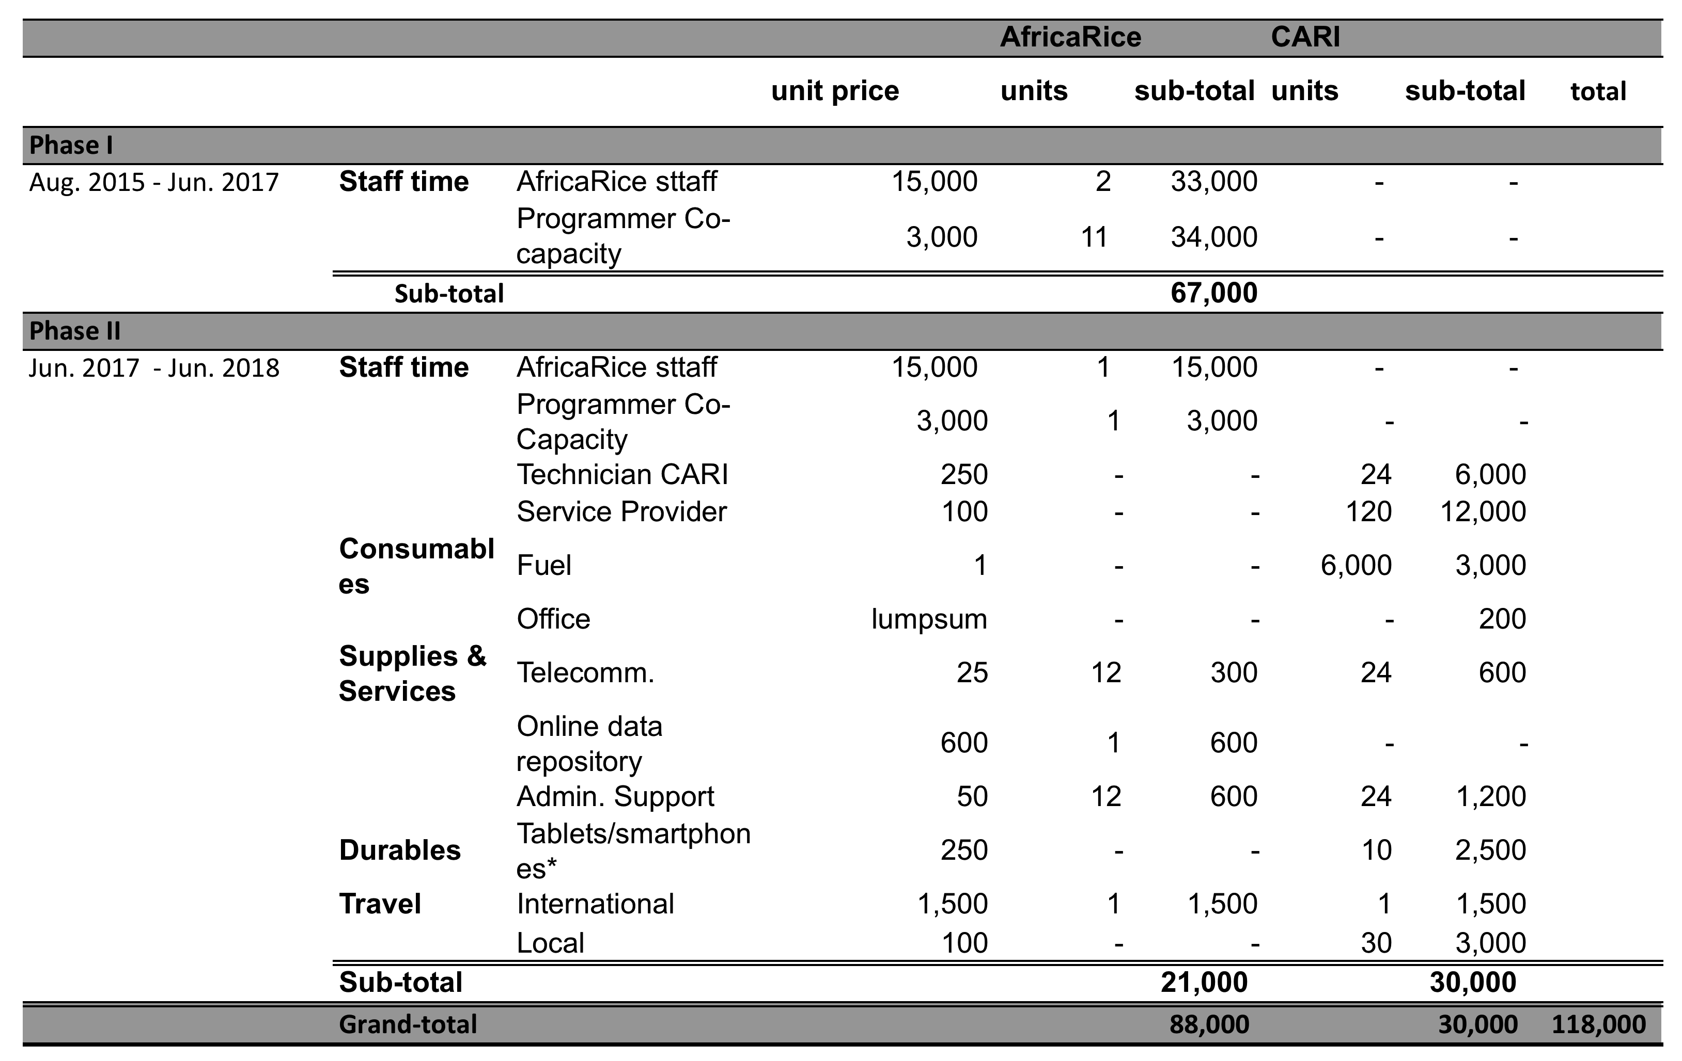
* Tablets/smart-phones are assumed to be already available for service providers in Nigeria.
Fig 1. Screenshots of RiceAdvice-WeedManager
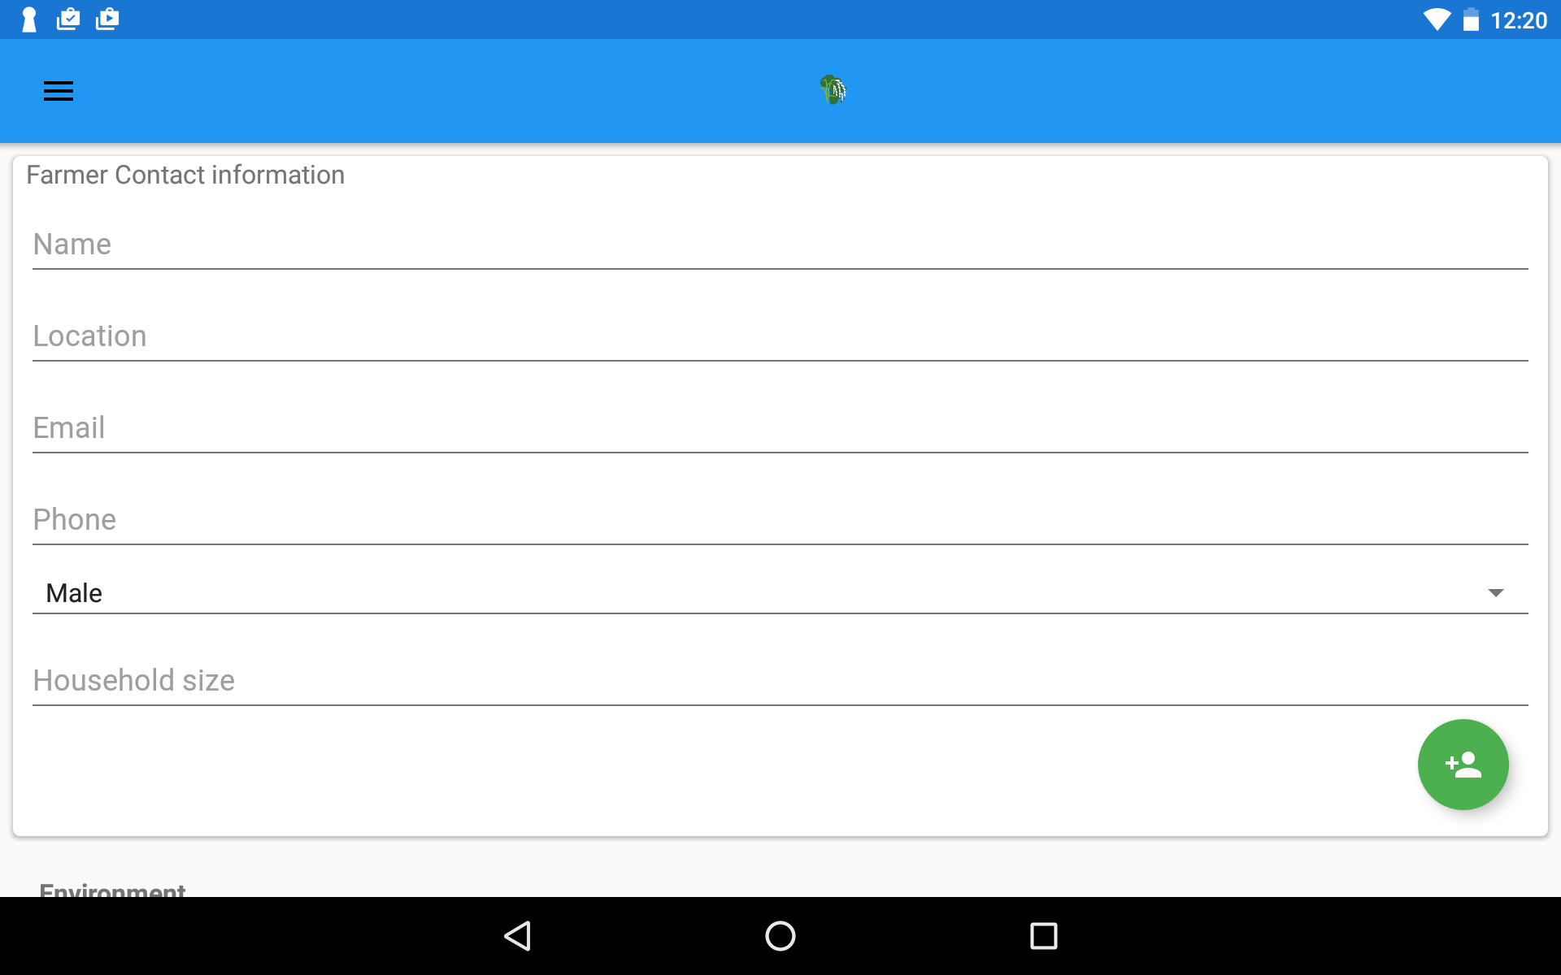
(a) Farmer identification
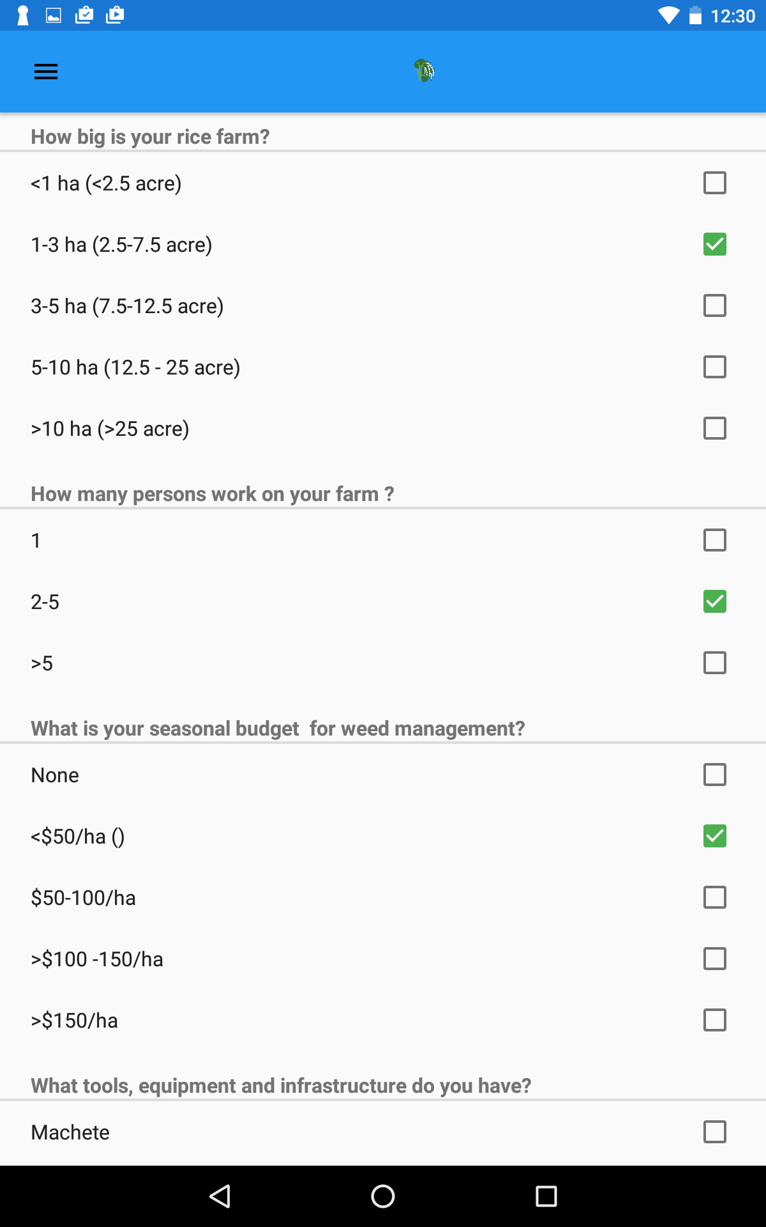
(b) Questions to create farm-specific profile

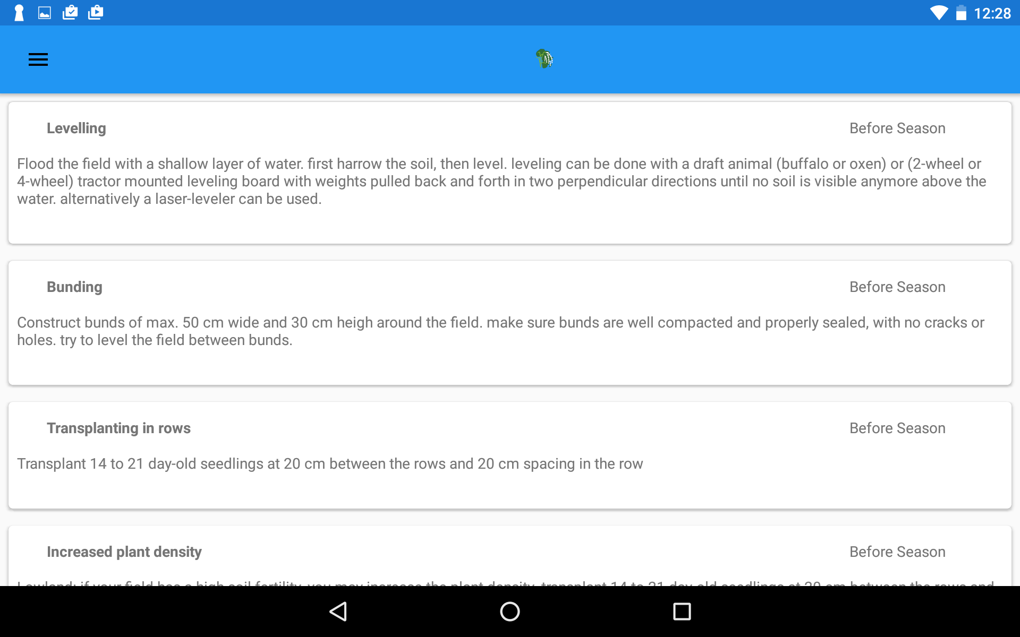
(c) Farm-specific recommendations

Fig. 2. Infographic RiceAdvice-WeedManager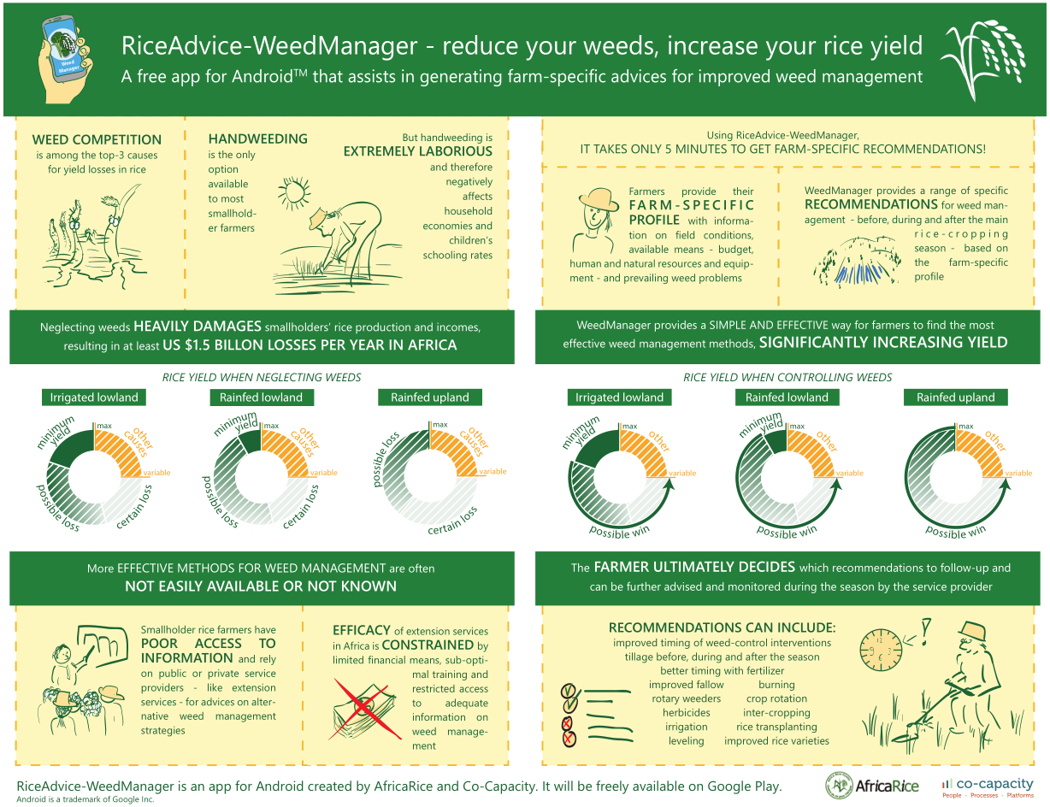

Annex 1: RiceAdvice

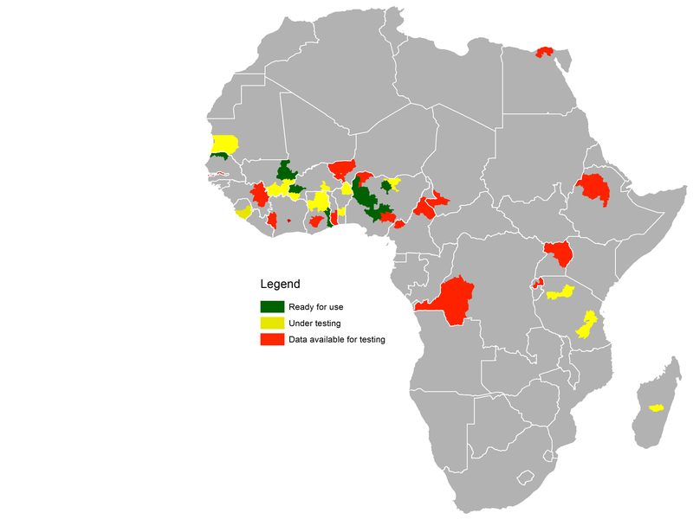
RiceAdvice is an Android based decision support tool for providing farmers with pre-season field-specific management guidelines for rice production systems in Africa.
It is an interactive tool, generating recommendations based on farmers’ answers to multiple choice questions on crop management practices and market. Expected users include farmers, extension workers, private rice sectors, development agencies in Africa who are interested in advice for rice production.
RiceAdvice can be used on Android devices (version 4.2 and up). Although RiceAdvice can be largely used without an internet connection, an active connection is required from time to time to synchronize information with the database server.
RiceAdvice is well received. Results from a Japanese funded project in Mali and Nigeria show an average gain of 100 US $ per hectare.
RiceAdvice Availability (August 2016)

Website: http://www.riceadvice.info

Annex 2. Protocol for on-farm testing trial for RiceAdvice-WeedManager

Objective
- To evaluate the use of WeedManager based on its user friendliness, ease of operation, and relevance of advices and ultimately, the potential for dissemination.
- Evaluate results of followed-up weed management recommendations (obtained from RiceAdvice-WeedManager) relative to results of farmers’ own weed management practices.

Approach
For each service provider an electronic tablet or smart-phone should be available. Android 4.1 or newer than 4.1 is highly recommended.
RiceAdvice-WeedManager recommendations will be followed up and established in a farmer’s field alongside his/her usual weed management practice. Ideally the farmer’s field should be split in two, more-or-less equal halves.
Data on actual crop management (of both the farmer’s practice and the WeedManager advices), field conditions, and yield will be determined through farm surveys prior and at the end of the season.

The following steps are required:
- In each country, 10 service providers will be selected and trained in the use of WeedManager and the follow-up with farmers during the year (half a day workshop).
- Among the demo farmers supported by CARI, 10 farmers will be selected per service provider. When selecting farmers, farm locations should be selected within a relatively small geographical area to minimize travel costs and time. Selected farms should also represent a relatively wide range of farm types/environments. This set-up can best be achieved by selecting service providers from different locations, such that environments/conditions between locations are different while the service providers him/her self can work in a relatively small area.
- Establish an agreement with each selected farmer, whereby
- The farmer agrees that half of his/her field will be ‘experimental’ and that on the other half he/she will follow the same management as in the previous year (including before-during-after season operations). The total farmer’s field will have a minimum size of 1 acre (≈4,000 m²).
- The service provider and CARI technician will remind the farmer of different activities to undertake and provide technical guidance but will not provide financial assistance.
  - Farmers allow service providers/extension, local government, and research personnel to periodically monitor the field evaluation and record information.
  - Farmers allow a field day and field visits for neighboring farmers.
  - Farmers allow the CARI technicians to harvest and thresh the paddy from a 5 × 5 m observation area in both halves of his/her field.
- The service provider/CARI-technician interviews each selected farmer to obtain necessary base-line information on ‘farmer practice’ and yield levels obtained in the past year (Form 1).
- The service provider/CARI technician will make farmer profiles with each of the participating farmers and generate up to three different recommendations for each farmer. The different recommendations will be discussed with the farmer and based on his/her willingness and capacity to invest one recommendation will be chosen and followed-up during the year.
- The service provider/CARI technician will save the WeedManager recommendation on the tablet and makes sure that advices are being implemented in time by the farmer. Farmer and village names and phone number are keys for identification of farmers. All this information will also be captured in field books (Form 1).
- The service provider/CARI-technician follows up with each farmer on the actual equipment and inputs used during the year and the costs made in terms of purchase of these inputs and on the time spent on weed management (per unit land area). This information will be collected for both the ‘farmer practice’ and the ‘WeedManager’ half of the field.

Implementing the field evaluation and data collection
The following will be handled by the assigned service provider/CARI-technician:
- Separate the farmer’s field in two halves by a bund, to avoid mutual influences of different management practices. One half will be ‘farmer practice’ and the other half will follow ‘WeedManager’ recommendations.
- In each half of the field mark out 5 × 5 m yield assessment and weed observation areas in the middle of the plot.
- This 25 m² observation areas will be used for weed observations and crop performance at mid-season and at harvest.
- Other observations, like accountancies of time and other inputs, will be done over the whole plot (Form 1).
- Record the actual date and modalities of interventions and inputs in each plot in Form 2.
- Record paddy yield for each plot in Form 3 following:
- At crop maturity, harvest all the hills/plants in the middle 25 m² (5 × 5 m) harvest area of each of the two treatment plots.
- Thresh and clean the grain. Place all grain into bags labeled for each treatment.
- Weigh each bag to determine total grain weight for each sample.
- Measure grain moisture content using a moisture meter for each treatment (can be borrowed from AfricaRice).

Form 1– Actual weed management practices

1 | Basic Information
1.1 | Location name (country & district)
1.2 | Village name
1.3 | Farmer name
1.4 | Phone number
1.5 | Visiting date/month/year
2 | General Information
2.1 | Rice production environment | 1: Irrigated lowland 2: Rainfed lowland 3: Rainfed upland
2.2 | Main weed categories | 1. Annual grasses – 2. Perennial grasses – 3. Annual sedges – 4. Perennial sedges – 5. Annual broadleaved – 6. Perennial broadleaved – 7. Parasitic – 8. Aquatic
2.3 | Unimodal/bimodal rainfall | 1:Unimodal 2: biomodal rainfall
2.4 | Estimated yield levels previous season (kg ha⁻¹)
2.5 | Field size (m2; only of field for which WeedManager generates advice)
2.6 | Number of people working on farm
2.7 | Weed management (for rice field only) budget per season (in local currency, please specify currency)
2.8 | Available inputs/equipment | 1. machete, hoe, push weeder, ring hoe, rotary weeder, motorized weeder  2. power tiller, cultivator, tractor, oxen plough  3. drainage canals, irrigation canals, motor pump  4. leveling board, laser leveler  5. transplanting machine  6. seeder  7. line tracers, ropes  8. herbicides: pre-mergence, post-emergence, broad-spectrum  9. herbicide sprayer, protective gear  10. fertilizers, compost, rice husks, straw  11. certified, quality seeds  12. others (describe)
3 | Weed Management Practices – BEFORE season
 |  | Farmer Practice (indicate 0=No, 1=Yes) | WeedManager Practice (indicate 0=No, 1=Yes)
3.1 | Off-season tillage
3.2 | Pre-season tillage
3.3 | Burning
3.4 | Herbicide - broad spectrum/non-selective
3.5 | Flushing/cleaning irrigation canals
3.6 | Pre-season flooding
3.7 | Pre-season drainage
3.8 | False seedbed
3.9 | Puddling
3.10 | Bunding
3.11 | Levelling
3.12 | Zero-tillage
3.13 | weed competitive varieties
3.14 | Striga asiatica resistant varieties
3.15 | Striga hermonthica/ S. aspera resistant varieties
3.16 | Rhamphicarpa resistant/tolerant varieties
3.17 | Others (describe)
 | Estimated Time Inputs (man hours —for above indicated field size)
 | Estimated Costs (indicate local currency —for above indicated field size)
4 | Weed Management Practices – DURING season
 |  | Farmer Practice (indicate 0=No, 1=Yes) | WeedManager Practice (indicate 0=No, 1=Yes)
4.1 | Prevent weed flowering/seed setting/vegetative propagation
4.2 | Use of weed-free seed/seedlings
4.3 | Seed pre-germination
4.4 | Intercropping
4.5 | Sowing in rows
4.6 | Transplanting in rows
4.7 | Increased plant density
4.8 | Mulching - organic
4.9 | Hand weeding
4.10 | Hoe weeding
4.11 | Push weeder
4.12 | Ring hoe
4.13 | Rotary weeder - without floater
4.14 | Rotary weeder - with floater
4.15 | Motorized paddy weeder
4.16 | Timely fertilizer application
4.17 | Herbicide - pre-emergence
4.18 | Herbicide - post-emergence
4.19 | Continuous flooding
4.20 | Drainage
4.21 | Others (describe)
 | Estimated Time Inputs (man hours)
 | Estimated Costs (indicate local currency)
5 | Weed Management Practices – AFTER season
 |  | Farmer Practice | WeedManager Practice
5.1 | Improved fallow >1 season
5.2 | Improved fallow - off-season only
5.3 | Crop rotation (within the above-indicated field)
5.4 | Prevent weed flowering/seed setting/vegetative propagation
5.5 | Others (describe)
 | Estimated Time Inputs (man hours)
 | Estimated Costs (indicate local currency)

Form 2 – Data collection at harvest
1.1 | Location name
1.2 | Village name
1.3 | Farmer name
1.4 | Phone number
1.5 | Harvesting date
 |  | Farmer Practice | WeedManager Practice
1.6 | Did your actual weed management differ from the above indicated practices? If yes, please describe
1.7 | How much time did you spend on weeding this season? (in man hours for the field indicated above)
1.8 | How much money did you spend on weed management this season? (in local currency for field indicated above)
1.9 | Did you pay someone for a weed management service on your field this season? (No=0, Yes=1)
1.10 | How much would you be willing to pay a service provider per season for the above indicated field to take care of your weeds?

Complete the following form through interview of each farmer.
2.1 | Was the rice growing season normal compared with previous seasons? | 1: Normal  2: Better  3: Worse
2.2 | If ‘Worse’ is selected in 2.1, which major constraint did you face? | 1: Poor or delayed land preparation  2: Poor crop establishment  3: Drought  4: Limited water access due to problem with irrigation  5: Submergence  6: Extreme temperature  7: Low solar radiation  8: Any soil-related problem  9: Weeds  10: Diseases and insects  11: Rats  12: Birds  13: Hailstones  14: Other (please specify)
 |  | Farmer Practice | WeedManager Practice
2.3 | Was field properly tilled in terms of depth?  ‘Good’ indicates that tillage was done deeply. | 1: Good (>15cm)  2: Intermediate  3: Bad (<5cm) | 1: Good (>15cm)  2: Intermediate  3: Bad (<5cm)
2.4 | Was field properly leveled?  ‘Good’ indicates that field is horizontally flat, whereas ‘bad’ indicates that no leveling was done or even though leveling was done, field is sloped. | 1: Good  2: Intermediate  3: Bad | 1: Good  2: Intermediate  3: Bad
2.5 | Select description of water supply in farmer’s field during rice growing season. | 1: Water supply was adequate.  2: There was moderate shortage of water.  3: There was severe shortage of water.  4: There was flooding problem. | 1: Water supply was adequate.  2: There was moderate shortage of water.  3: There was severe shortage of water.  4: There was flooding problem.
2.6 | Select description of weed pressure in farmer’s field in this year. | 1: Growth and yield was reduced by weeds.  2: Weeds did not cause yield reduction. | 1: Growth and yield was reduced by weeds.  2: Weeds did not cause yield reduction.
2.7 | Select diseases and insects in farmer’s fields. | 1: There was yield reduction due to diseases/insects.  2: No or minor yield reduction due to diseases/insects. | 1: There was yield reduction due to diseases/insects.  2: No or minor yield reduction due to diseases/insects.
2.8 | Select description of bird damage in farmer’s field. | 1: Severe yield reduction due to birds.  2: Moderate yield reduction due to birds.  3: No yield reduction. | 1: Severe yield reduction due to birds.  2: Moderate yield reduction due to birds.  3: No yield reduction.
2.9 | Select description rat damage in farmer’s field. | 1: Severe yield reduction due to rats.  2: Moderate yield reduction due to rats.  3: No yield reduction. | 1: Severe yield reduction due to rats.  2: Moderate yield reduction due to rats.  3: No yield reduction.

Form 3 – Yield assessment
Complete the following form for each selected farmer cooperator during the harvest of the crop in each plot (observation area of 5 × 5 m). Please refer to the Yield Assessment explanation above.
1.1 | Location name
1.2 | Village name
1.3 | Farmer name
1.4 | Phone number

 | Farmer Practice | WeedManager Practice
Total weight of plot filled grains (kg)
Moisture content of filled grains (%)

